Please distribute this alert to any users within your agency who are responsible for benefit enrollment.

Updating SAP for Same Sex Marriages

- Information regarding updating SAP in regards to same sex marriages

On May 20, 2014, the United States District Court for the Middle District of Pennsylvania ruled that same-sex couples who seek to marry in Pennsylvania may legally do so, and that same sex couples validly married in another state or country will be recognized as married in Pennsylvania.

In order to properly document the update of the same-sex marriage in SAP and to remove the imputed income from being taken from the employee, the following steps should be executed in SAP.

- The Personal Data (IT0002) screen should be copied and updated to reflect married in SAP effective 5/20/2014 (if the date on the marriage certificate is prior to 5/20/2014) or the date of the marriage certificate (if the date is after 5/20/2014).

Screen shot of IT0002

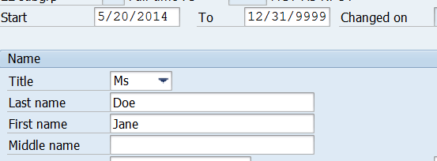

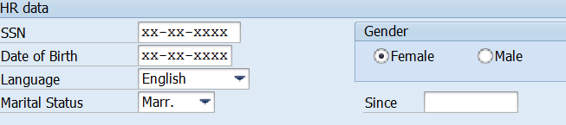
This date should reflect the date of the marriage certificate. NOTE: It may not be the same as the start date of the record.

- On the Family Member/Dependents (IT0021) screen, create a spouse record effective 5/20/2014 (if the date on the marriage certificate is prior to 5/20/2014 or the date of the marriage certificate (if the date is after 5/20/2014). Please note: The domestic partner record (ZA) should be delimited the date prior to the effective date of the marriage or 5/20/2014, whichever is later.

Screen shot of IT0021

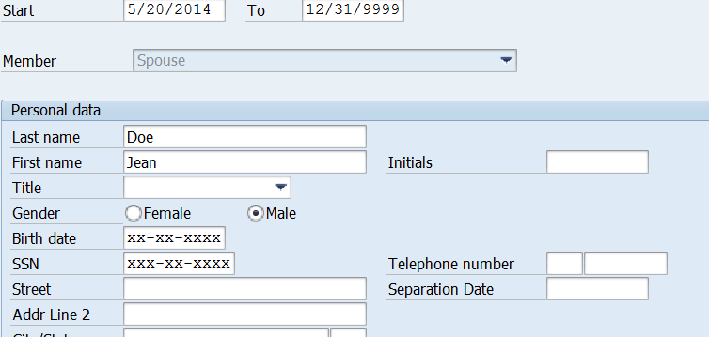

- The Display Health Plans (IT167) screen should be updated to reflect the cost rule variant as “Employee + Family” effective the date of marriage. This will update in the background when the benefit enrollment is processed through the HRBEN0001. The start date of the HRBEN0001 record should be the effective date of the marriage or 5/20/2014, whichever is later.

Screen shot of IT167

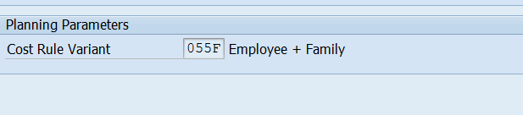

*Please Note: SAP updates for same-sex marriages should only be processed for the current calendar year. Employees wanting to take corrective action to adjust their taxes prior to the current calendar year will have to pursue corrective action with a tax professional.

Agencies not served by the HR Service Center should follow the above instructions to make the necessary changes in SAP.

For those agencies served by the HR Service Center, SAP has already been updated to reflect the above changes for the affected employees.

Any inquiries regarding same-sex marriages, including the states that have legalized same- sex marriages, effective dates of legalization, and validity of marriage documentation should be directed to ra-benhelp@pa.gov.

Questions?
If you have any questions regarding Updating SAP for Same Sex Marriages, please submit an HR help desk ticket in the benefits category. You may also call the HR Service Center, Agency Services & Operations Division at 877.242.6007.

