Please distribute this alert to any users within your agency who are responsible for benefit enrollment.

Adding/Updating Work and Cellular Phone Numbers in SAP

- Information regarding adding/updating work and cell phone numbers in SAP

A program change has been made to the PEBTF file format as it relates to the employee work number. In the past, the work number was retrieved from IT0006 – Addresses, Subtype 10 (Work Address). This subtype is only created when an employee has a workers’ compensation claim and often times, the work number is outdated. Moving forward, the employee work number will be retrieved from the IT0006 – Addresses, Subtype 1 (Permanent Residence), Type – Work as shown below in the “Communications” box.

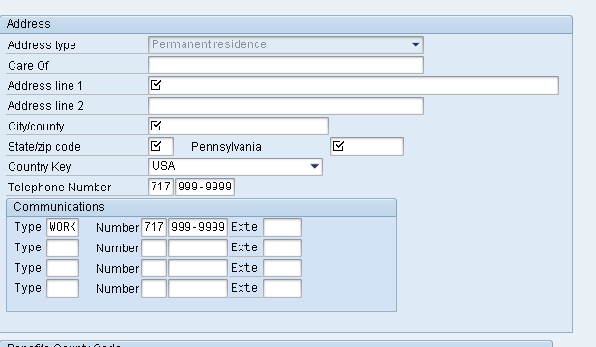

To add or update the work number in SAP:

- PA 30, COPY, IT0006 – Addresses, Subtype 1 (Permanent Residence), Type – Work

- The work number should not be added to Subtype 5 (Mailing Address) as this data will not be passed to the PEBTF

- If multiple work numbers exist, only the first number will be passed to the PEBTF

Many employees no longer have a home telephone number and use a cellular number as their main contact number. In order for the correct number to transmit to the PEBTF, the following procedures should be followed to add/update a cellular number in SAP using PA30, COPY:

- If an accurate home telephone number is present on IT0006 – Addresses, Subtype 1 (Permanent Residence) in the “Telephone Number” field, the cellular number should be added to the “Communications” box, Type – Cell as shown below. In this scenario, the cellular number will not be passed to the PEBTF.

- If an employee does not have a home telephone number and uses their cellular number as their primary phone number, the cellular number should be added to IT0006 – Addresses, Subtype 1 (Permanent Residence) in the “Telephone Number” field. This will ensure that the cellular number is transmitted to the PEBTF as the main contact number.

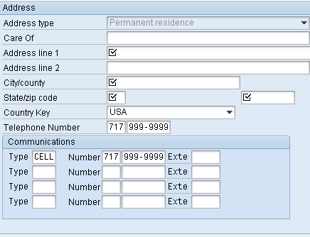
Enter cell phone number here if it is in addition to the home telephone number above. This number will not transmit to the PEBTF.
Enter cell phone number here if there is no home telephone number and this is the primary contact number.

Questions?
If you have any questions regarding Adding/Updating Work and Cellular Phone Numbers in SAP, please submit an HR help desk ticket in the benefits category. You may also call the HR Service Center, Agency Services & Operations Division at 877.242.6007.

