***Please distribute this alert to any users within your agency who are responsible for transactions and benefit enrollments.***

**Implementation of Great-West Interface file and Availability of New Roth 457 Savings Plan**

* Information regarding the implementation of a Great-West interface file and the addition of a new Roth 457 plan

Effective August 1, 2012, the following changes will occur with the deferred compensation program:

* A new Roth 457 savings plan will be available
* Employees can utilize Great-West’s website account management tools, automated voice response system or customer service call center to make changes to their deferred compensation deductions. Employees are still required to meet with a Great-West Representative to enroll in the program.
* Great-West will implement a weekly inbound interface file with the commonwealth for the creation of and changes to employee deferred compensation and/or Roth deductions. This will eliminate the need for manual processing. **Exception:** Requests for a leave rollover into deferred compensation/Roth will not be sent in the interface file. Great-West will continue to send rollover forms for manual processing to the HR Service Center or agencies not supported by the HR Service Center.

The implementation timeline is as follows:

**July 20** – Last day for Great-West to submit bi-weekly deduction forms to the HR Service Center/HR Office for manual processing

* If forms are received after July 20th, return them via fax to Great-West at

1-717-901-3620

* Great-West will continue to submit requests for leave rollovers for manual processing

**July 23-24** – All forms received through July 20 must be input by HR Service Center/HR Office

**July 25** – Conversion of all current deferred compensation enrollments in SAP to the new deferred compensation plan with an effective date of August 1, 2012

**August 1** – Great-West online system and new Roth 457 plan will be available to employees

**August 2** – First inbound production file received from Great-West

This change will apply to all agencies serviced by the HR Service Center in addition to: Liquor Control Board, Attorney General, Pennsylvania Utilities Commission, Gaming Control Board, Port Authorities and Health Care Cost Containment Council.

Highlights of the Roth 457 plan are:

* Deductions are taken on a post-tax basis
* Employees may elect to defer their leave payment to the Roth plan
* Age and annual deduction limits are consistent with the existing deferred compensation plan
* Employees may elect to enroll in both deferred compensation and Roth. If enrolled in both plans:
  + Deductions will be taken first from the deferred compensation plan and secondly from the Roth plan
  + Annual contributions cannot exceed the annual maximum limits based on the total contributions for both plans
    - $17,000 based on regular enrollment
    - $22,500 for age 50 catch-up
    - $34,000 for special catch-up (within 3 years of normal retirement date)

In order to implement the new Roth 457 plan, a reconfiguration of the deferred compensation program in SAP was required. The following SAP changes have been made:

* Creation of new plan type
  + ROTH – Roth 457
* Benefit plans will be locked effective 8/1/2012
  + DEFR – Deferred Comp Regular
  + DEFC – Deferred Comp Catch-up
* Creation of two new benefit plans
  + DCMP – Deferred Comp
  + ROTH – Roth 457
* Creation of new wage types for each benefit plan
  + DCMP
    - 6E74 Deferred Compensation (is currently used)
    - 6E7C Deferred Comp Catch-up
  + ROTH
    - 6E68 Roth 457
    - 6E6C Roth 457 Catch-up
* Validation will occur based on:
  + The presence of a retirement record on IT0169 – Savings Plan
  + DOB – for Age 50 Catch-up
    - Identifies employees eligible to defer an additional $5,500 for a total of $22,500 in a calendar year
    - Contributions will stop at $22,500 annually
  + The presence of a NR - Normal Retirement Dt on IT0041 – Date Specifications
    - Identifies employees eligible to defer the maximum of $34,000 in a calendar year based on being within 3 years of their Normal Retirement Date (NRD)
  + The presence of Wage Type - /PCU – 457 Unutilized Amount on IT0015 – Additional Payments
    - Identifies the underutilized amount that an employee can contribute during the 3 years prior to their NRD up to a maximum of $34,000 annually. The default amount for this field is $60,000.
    - Once an employee reaches $34,000 in a calendar year and/or they have contributed all of the underutilized amount over a three year period, the deductions will stop for the calendar year.
* Separation actions
  + All new plan codes will be delimited with the separation action effective the last day of the pay period in which the employee separates.
* All employees currently enrolled in the deferred compensation program will be converted to the new DCMP – Deferred Comp benefit plan with an effective date of August 1, 2012.

The following table shows the new SAP plans and associated wage types:

|  |  |  |  |  |  |
| --- | --- | --- | --- | --- | --- |
| **IT0169 - Plan** | **IT0169 - Benefit Plan** | **IT0169 - Benefit Plan Text** | **IT0014 - Wage Type** | **IT0014 - Wage Type Short Text (8 positions)** | **IT0014 - Wage Type Long Text** |
| DEFR | DCMP | Deferred Comp | 6E74 | 6E74DCMP | Deferred Compensation |
|  |  |  | 6E7C | 6E7CDCMC | Deferred Comp Catch-up |
|  |  |  |  |  |  |
| ROTH | ROTH | Roth 457 | 6E68 | 6E68ROTH | Roth 457 |
|  |  |  | 6E6C | 6E6CROTC | Roth 457 Catch-up |

The following table depicts how the deferred compensation/ROTH contributions will be applied based on the new configuration:

|  |  |  |  |  |
| --- | --- | --- | --- | --- |
| **Eligibility Type** | **Annual Max** | **Def Comp - Wage Type** | **Roth - Wage Type** | **Comments** |
| < Age 50 | $17,000 | 6E74 | 6E68 | Amounts up to $17,000 will be reflected under WT 6E74 and/or WT 6E68 |
| >Age 50 | $22,500 | 6E7C | 6E6C | Amounts reflecting the Age 50 catch-up will be reflected under WT 6E7C and/or WT 6E6C and will never reflect more than $5,500 based on the current limits |
| Within 3 years of normal retirement date | $34,000 | 6E74 | 6E68 | Once an employee is within 3 years of normal retirement date and has elected the special catch-up, all contributions will revert to original wage types WT 6E74 and/or WT 6E68. **Age 50 catch-up and special catch-up cannot be utilized in the same calendar year.** |

**Processing instructions for July 23-24, 2012:**

|  |  |
| --- | --- |
| **Bi-weekly contributions** | * Enrollments with an effective date prior to 8/1/2012, use the existing DEFR and DEFC plans. * Enrollments with an effective date of 8/1/2012 or after, use the new DCMP plan (it is unlikely that forms will be received during the transition period with an effective date of 8/1/2012). |
| **Leave rollovers** | * If the payout is effective during the pay period containing 8/1/2012 or after, use the new plan DCMP. * If the payout is effective prior to the pay period containing 8/1/12, use the current DEFC plan. |

The following are SAP screenshots (effective August 1) based on various types of enrollments.

**SCENARIO #1 – Employee is currently enrolled in Deferred Compensation. Employee elects to change DCMP deduction to 10% and enroll in ROTH with a 75% contribution. Employee is also eligible for the Age 50 Catch-up. Deduction changes are received through the interface file to update SAP.**

**IT0169 – Savings Plan Overview:** The 8/1/12 record represents the conversion record from the old DEFR plan to the new DCMP plan. The 8/5/12 records reflect the records created as a result of the inbound interface file in which the employee changed their DCMP deduction and enrolled in ROTH.

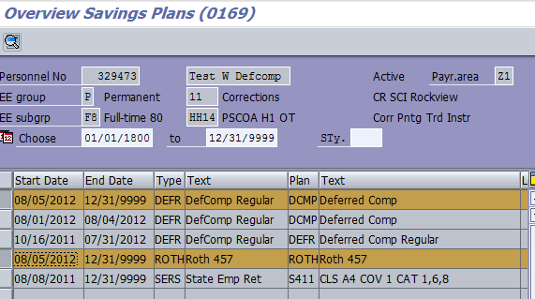

Created by interface

**IT0169 – Savings Plan:** 8/5/2012 record shows a 10% pre-tax contribution in DCMP.

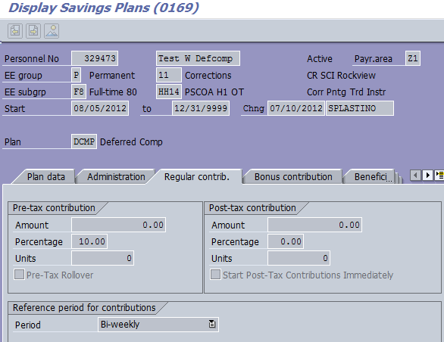

**IT0169** - **Savings Plan -** 8/5/2012 record shows 75% post-tax contribution in Roth 457.

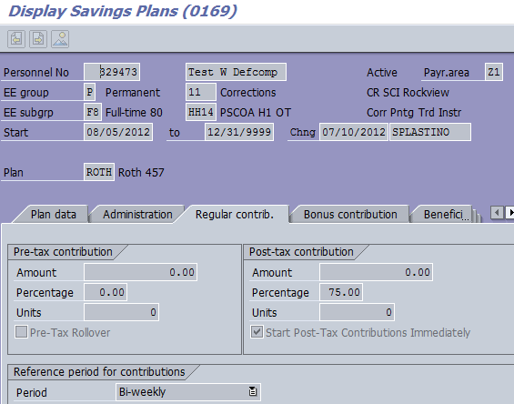

**Period 18/2012:** First pay date with both DCMP and ROTH deductions and reflects a $1144.96 (10%) DCMP deduction (WT 6E74) and $6013.44 (75%) ROTH deduction (WT 6E68).

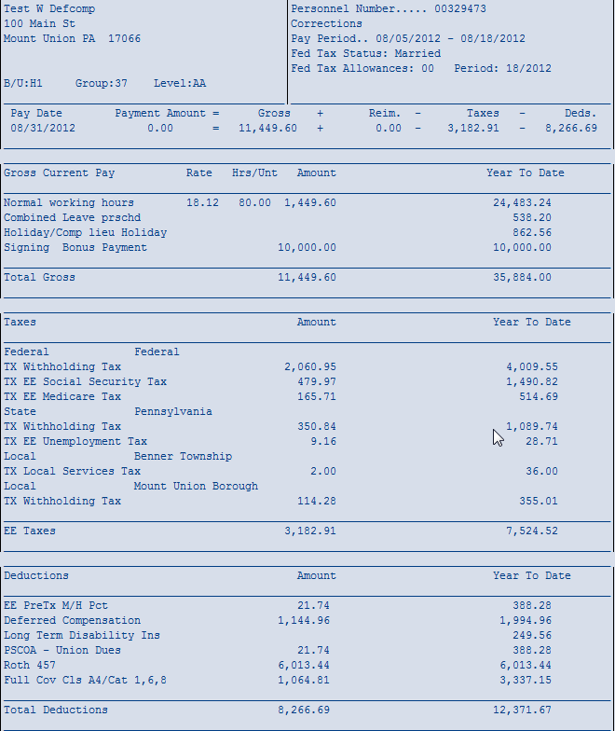

WT 6E68

WT 6E74

**IT0002 – Personal Data:** Employee turned 50 in 2010 and as a result is eligible for the Age 50 Catch-up for an additional $5,500 for a maximum annual contribution of $22,500 in 2012.

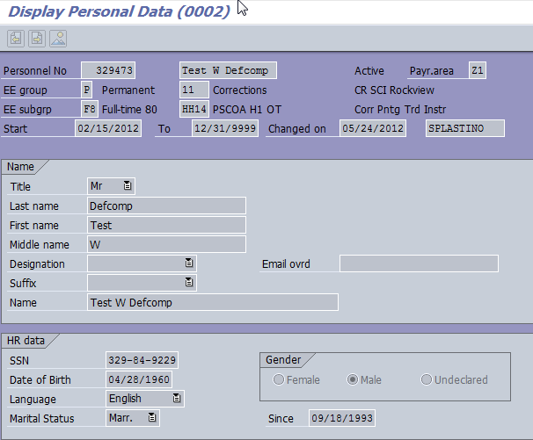

Eligible for Age 50 catch-up

**Period 19/2012:** Reflects employee reaching annual maximum of $17,000 for deferred compensation and Roth combined. Employee begins contributing toward the additional $5,500 based on eligibility for Age 50 Catch-up. No catch-up deduction was applied to the DCMP due to the fact that the regular deduction already equaled 10%.

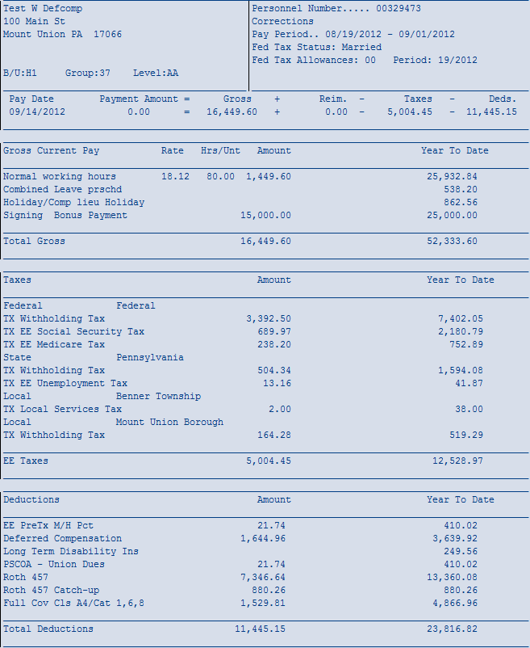

Contributing towards additional $5,500

Deductions total $17,000

WT 6E6C

**Period 20/2012:** Employee reaches maximum of $22,500 and will not have any deductions for the remainder of 2012.

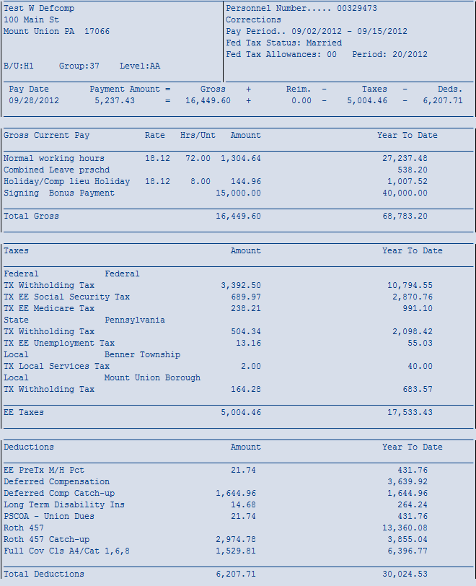

Contributions total $5,500

**Benefits Participation Overview:** The Roth 457 is reflected on the Benefits Participation Overview showing the applicable deduction.

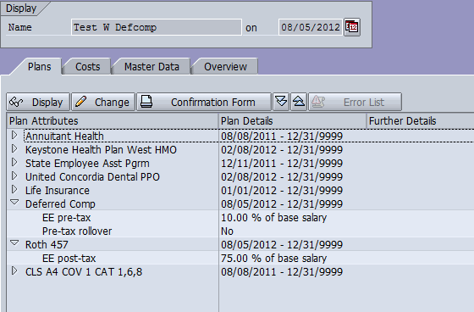

Participation Overview shows DCMP and ROTH 457 records with applicable deductions

**SCENARIO #2 – Employee is currently enrolled in Deferred Compensation. Employee has elected the special catch-up and has changed the DCMP deduction to $900 and enrolled in ROTH with a $4,000 deduction. Deduction changes are received through the interface file to update SAP.**

**IT0169 – Savings Plan Overview:** The 8/1/2012 record represents the conversion record from the old DEFR plan to the new DCMP plan. The 8/11/12 records reflect the records created as a result of the inbound interface file in which the employee has elected the Special Catch-up and has changed their DCMP deduction and enrolled in ROTH.

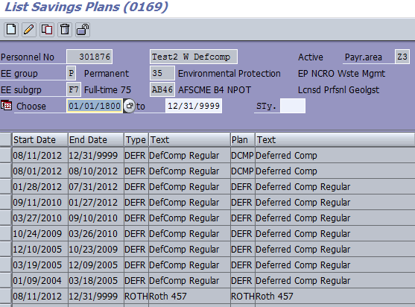

Created by interface

**IT0169 – Savings Plan:** 8/11/2012 record showing $900 pre-tax contribution in DCMP.

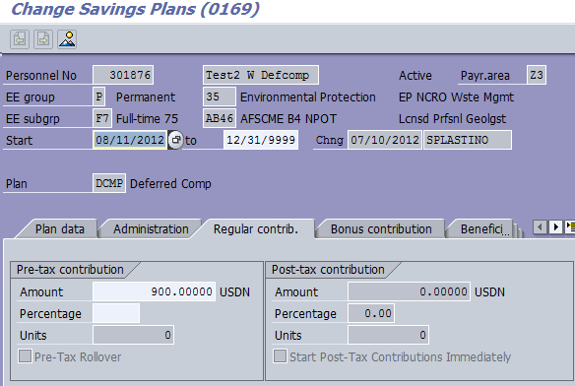

**IT0169 – Savings Plan:** 8/11/2012 record showing $4,000 post-tax contribution in Roth 457.

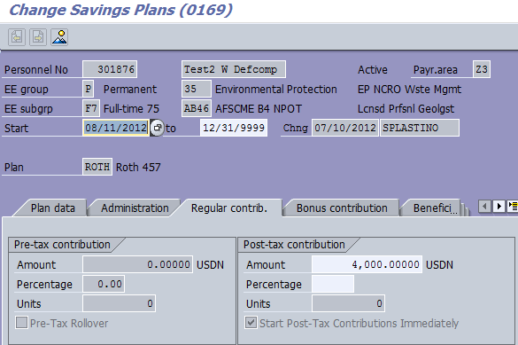

**IT0015 – Additional Payments, Sty /PCU – 457 unutilized amount:** The effective date (Date of origin) of the /PCU wage type will always be the period begin date of the pay period prior to the effective date of the catch-up election. The system default for the amount is $60,000.

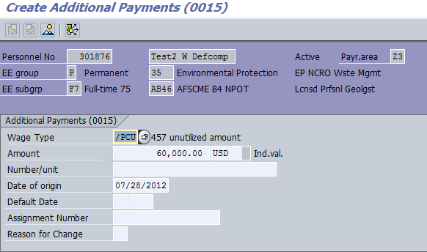

Employee elected special catch-up effective 8/11/12 and is in payroll area Z3. The period begin date of the pay period prior to 8/11/12 is 7/28/12.

Amount will default to $60,000

**IT0041 Date Specifications, NR – Normal Retirement Dt:** The start date of the record will always be the period begin date of the pay period prior to the effective date of the catch-up election. The Normal Retirement Dt identifies the calendar year in which the employee is no longer eligible to participate in the special catch-up. This will always reflect a 1.1.XXXX date. Based on the Normal Retirement Dt shown below, the employee will be eligible to defer the maximum of $34,000 thru 12/31/2014.

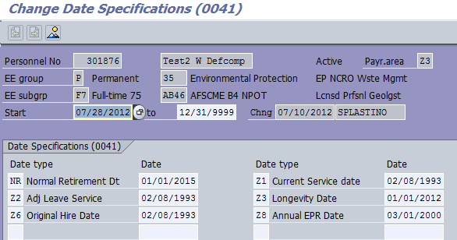

Based on the NR Date, employee will be eligible to defer the annual maximum of $34,000 thru 12/31/14.

Employee elected special catch-up effective 8/11/12 and is in payroll area Z3. The first day of the pay period prior to 8/11/12 is 7/28/12.

**Period 18/2012:** Employee exceeded the annual $17,000 and started contributing towards the special catch-up. All deductions are applied to the regular wage types of DCMP – WT6E74 and ROTH – WT6E68. Catch-up wage types are only used for the Age 50 Catch-up.

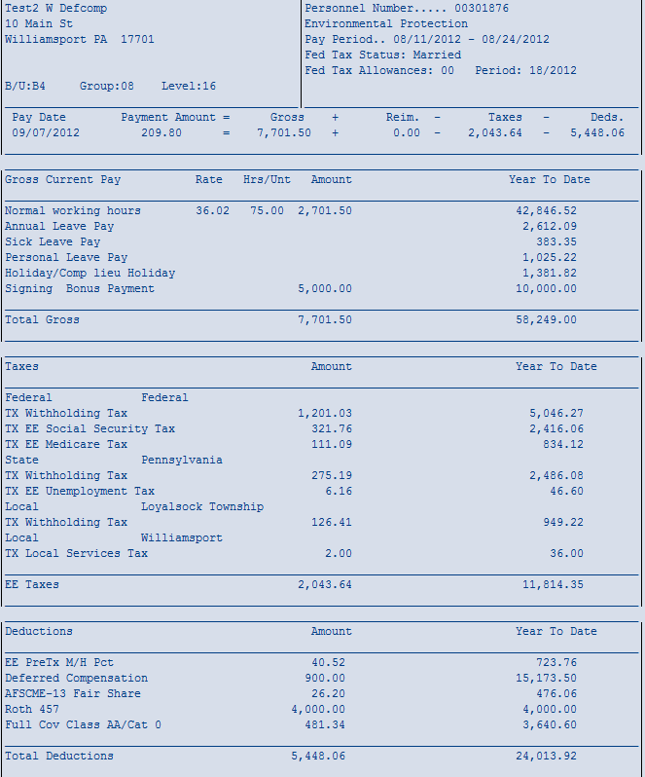

Employee now contributing in access of $17,000 combined

WT 6E74

WT 6E68

**Period 21/2012:** Employee has almost reached the maximum annual contribution of $34,000 and has $126.50 remaining.

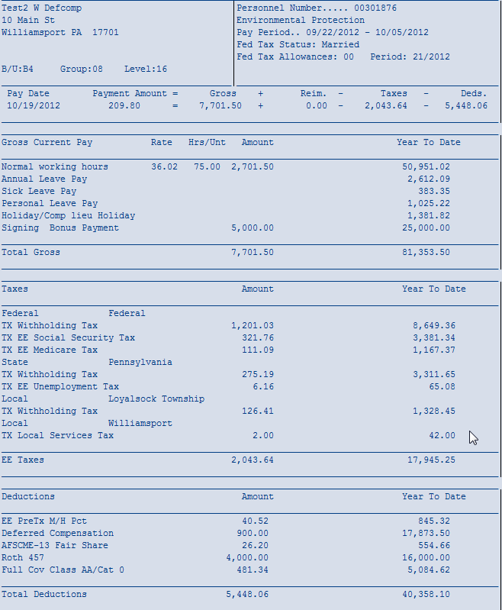

Total YTD is $33,873.50

Employee has contributed a combined total of $34,000

**Period 22/2012:** The remaining $126.50 was taken for DCMP. The DCMP deduction has priority over the Roth deduction, resulting in the deduction being applied to DCMP. Employee has now reached the maximum contribution of $34,000 and deductions will stop for 2012.

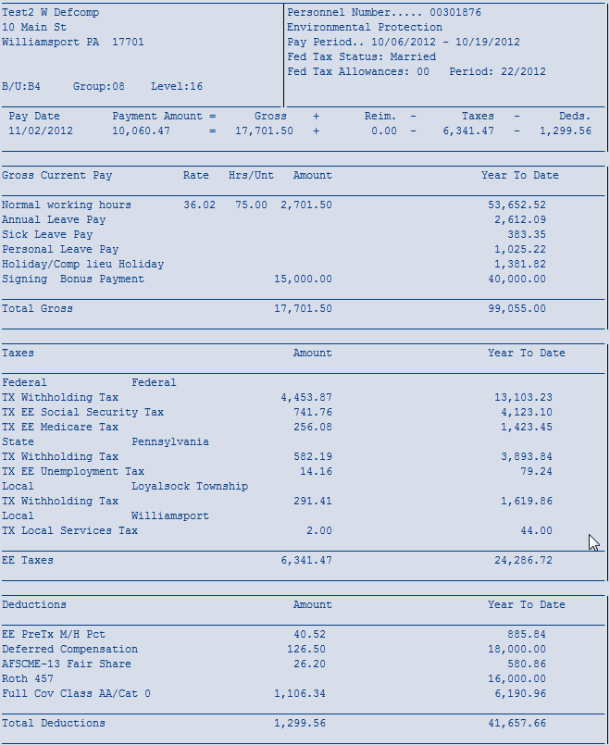

Combined total is $34,000

**SCENARIO #3 - Employee is separating effective close of business 9/7/12 and is in payroll area Z3. Employee has elected to contribute $32,200 of the leave payout into deferred compensation. An employee may elect to roll the leave payout into deferred compensation and/or Roth with the priority of deductions being the deferred compensation deduction will be taken first and any remaining from Roth. THIS IS A MANUAL PROCESS AND WILL NOT COME THROUGH ON THE WEEKLY INTERFACE FILE.**

**Period 18/2012:** This is the last pay prior to the separation and shows employee enrolled in DCMP (WT6E74) with a $100 deduction.

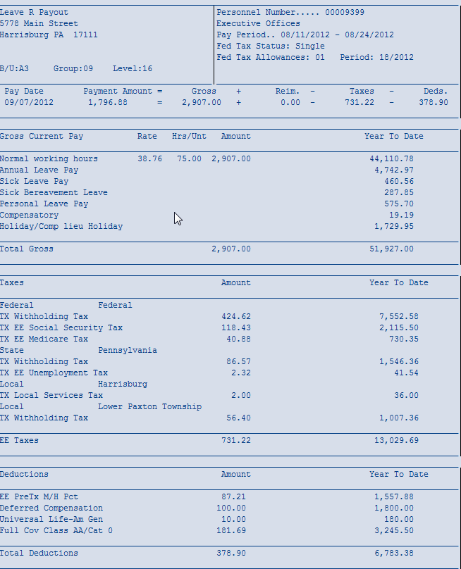

YTD $1,800 - Can defer an additional $32,200

WT 6E74

**IT0000 – Actions:** The separation action has been input effective 9/8/2012.

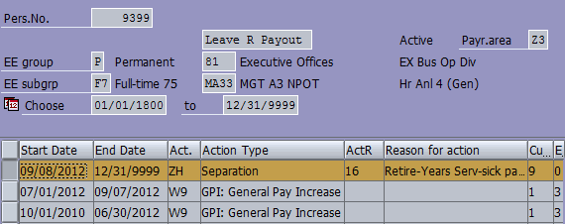

**IT2012 – Time Transfer Specifications:** The leave payout must be unlocked before the deferred compensation catch-up record can be input.

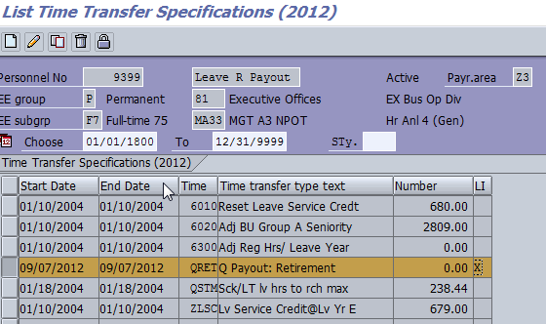

Unlock leave record

**HRBEN0001 – Benefit Enrollment:** The enrollment for the leave rollover must be effective the pay period in which the leave will be paid. If leave is unlocked timely, the leave will pay with the final pay. In this example, the leave will pay on 9/21/2012 so the enrollment is effective 8/25/12.

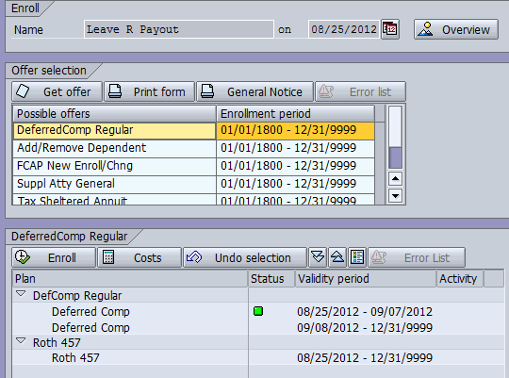

Change date to beginning of pay period in which the leave will pay

**NOTE:** The record above, dated 8/25/2012-9/7/2012, is the current record that was delimited with the separation in SAP. Because there is no longer a separate Deferred Compensation Catch-up plan, the user will select the current record to override the current amount with the leave rollover amount. If the leave does not pay timely, you would create a new record based on the first day of the pay period in which the leave pays.

If the employee is electing to use the Roth 457 plan for the leave rollover, you would select that plan option and enter the amount in the “Post-tax contribution bi-weekly” field. An employee may also elect both deferred compensation and Roth for the leave rollover; however, the deferred compensation deduction will be taken first.

Enter the amount of the rollover amount from the Salary Deferral Form.

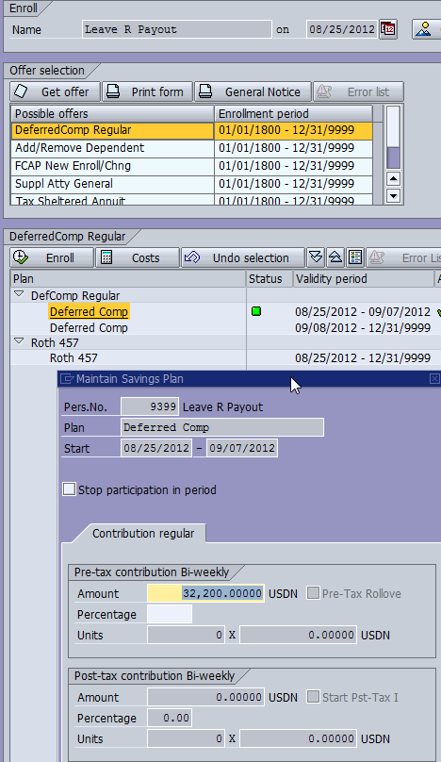

Enter the amount of the rollover amount from the Salary Deferral Form

**IT0169 – Savings Plan:** Record shows effective dates of 8/25/12 to 9/7/12 with an amount of $32,200. Please note you are no longer required to change the end date on the leave rollover record unless the leave payout does not pay timely with the final pay and a new enrollment must be created. In those cases, the end date would be 12/31/9999 when the enrollment is performed and would need changed thru a PA30 to reflect the last day in the pay period.

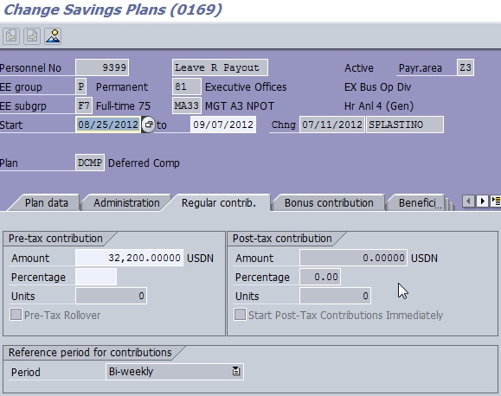

Only change end date if it reflects 12/31/9999

**IT0015 – Additional Payments:**  If the employee is already enrolled in the special catch-up, a record for Wage Type /PCU – 457 unutilized amount will already exist. **DO NOT CHANGE THE EXISTING RECORD.**

**If there is not a record for Wage Type /PCU – 457 unutilized amount, it must be created following the below steps:**

* PA30, IT0015, Sty /PCU, CREATE
* In the period section on the Maintain HR Master Data screen, enter the effective date which will always be the period begin date of the pay period prior to the effective date of your catch-up election. In this example, the deferred compensation rollover record is effective 8/25/12 and the effective date for the IT0015 record is 8/11/12.
* In the amount field enter $60,000 as the system default.
* The Date of Origin will populate based on the date you entered on the Maintain HR Master Data screen.

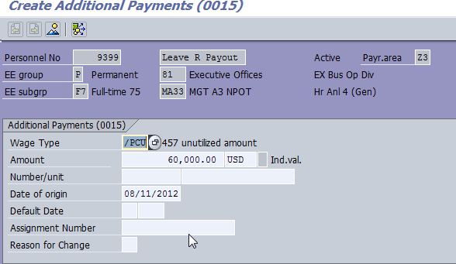

Enter $60,000 as the system default

Employee elected special catch-up effective 8/25/12 and is in payroll area Z3. The period begin date of the pay period prior to 8/25/12 is 8/11/12.

**IT0041 – Date Specifications:** If the employee is already enrolled in the special catch-up, a IT0041 record with Date Type NR – Normal Retirement DT will already exist. **DO NOT CHANGE THE EXISTING RECORD.**

**If there is not an existing record with an NR date, it must be created following the below steps:**

* PA30, IT0041, COPY
* Change the start date of the record to the period begin date of the pay period prior to the effective date of your catch-up election. In this example, the deferred compensation rollover record is effective 8/25/12 and the effective date for the IT0041 record is 8/11/12.
* In the Date Type field, select NR – Normal Retirement Dt from the drop down menu. Enter the date of 1.1.xxxx. The date is always January 1 of the year following the election of the special-catch-up for leave rollover purposes. In this example, the leave rollover is elected in 2012 resulting in an NR date of 1/1/2013.

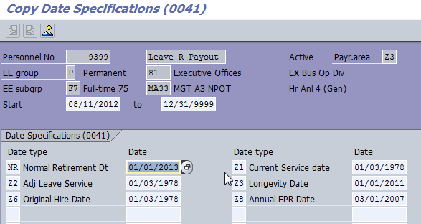

Date is always 1.1.XX of the year following the election of the special catch-up.

Employee elected special catch-up effective 8/25/12 and is in payroll area Z3. The period begin date of the pay period prior to 8/25/12 is 8/11/12.

**Period 19:** Includes accrued leave being paid, and the deferred compensation deduction of $32,200 is taken resulting in the employee contributing the maximum of $34,000.

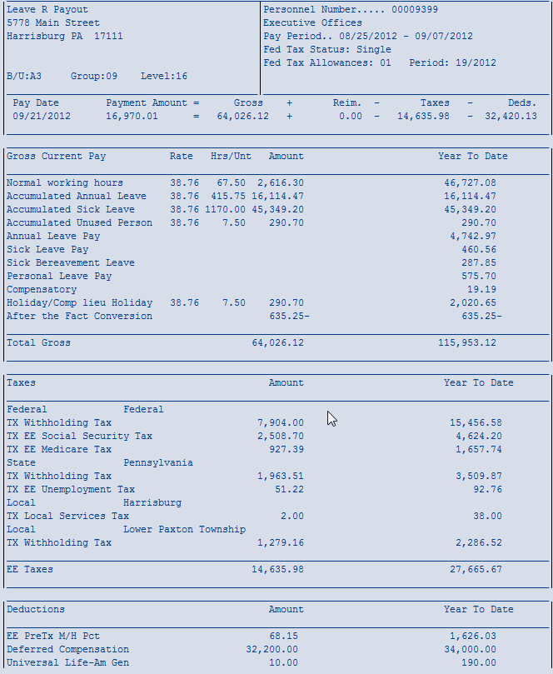

Special catch-up amount of $32,200 resulting in maximum YTD of $34,000

Accumulated leave payout

**Questions?**   
If you have any questions regarding this alert, please submit an [**HR help desk ticket**](http://oaiss.state.pa.us/HR-Pay_Help_Desk/) in the benefits category. You may also call the HR Service Center, Agency Services & Operations Division at 877.242.6007.